NAME :D DEVENDRA
REG NO :192525203
Ex. No. : 6
SELECT with various clause – BETWEEN, IN, Aggregate function
AIM:
To view the records from the tables using SELECT commands with BETWEEN, IN, Aggregate
functions.
IN & BETWEEN
1. List the type of the courses "Statistics" and "Programming"
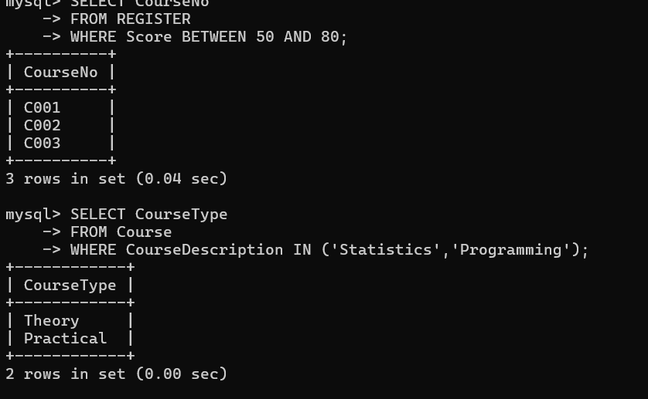
2. Display the CourseNos whose scores are between 50 and 80
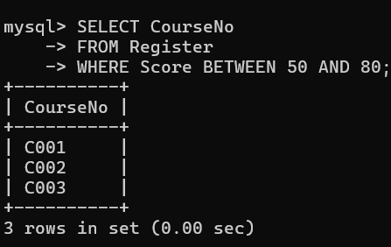
AGGREGATE FUNCTIONS
1. Find the average mark of "C002"

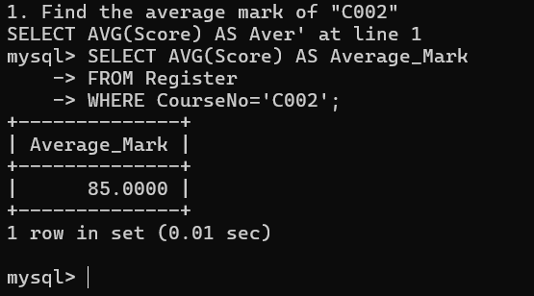
2. List the maximum and minimum mark for "C002"
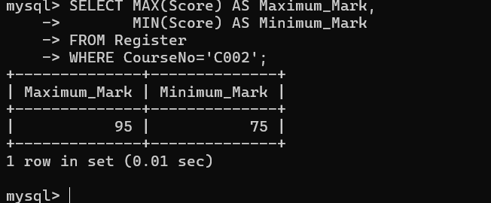
3. List the maximum, minimum and average mark for each course
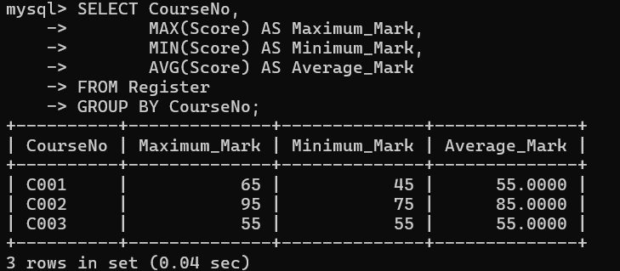
4. List the course name and average mark of each course
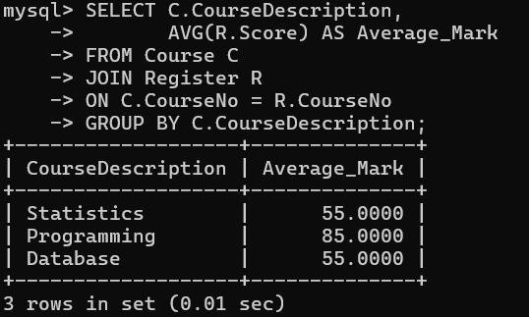
5. Calculate the sum of all the scores 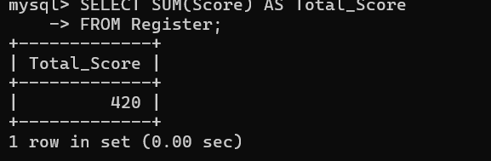
6. Display the course description and the number of students registered in each course
